**Project Report Template**

1. INTRODUCTION

1.1Overview

Human emissions of carbon dioxide and other greenhouse gases – are a primary driver of climate change – and present one of the world’s most pressing challenges. This link between global temperatures and greenhouse gas concentrations – especially CO2 – has been true throughout Earth’s history.

In 1950 the world emitted 6 billion tonnes of CO2. By 1990 this had almost quadrupled, reaching more than 22 billion tonnes. Emissions have continued to grow rapidly; we now emit over 34 billion tonnes each year. Emissions growth has slowed over the last few years, but they have yet to reach their peak.

1.2Purpose

Data analytics involves the collecting, analysing, and interpreting of data relating to carbon emission and energy usage for an organisation. To improve energy usage, and ultimately make commercial savings it is imperative that the starting point of the organisation is established. This benchmark can then be referenced in future years to show performance improvements to internal and external stakeholders and gain a competitive advantage within the market.

Data analysis highlights the areas where improvements can be made, the capital required for these, and the expected cost savings of each improvement, allowing organisations to make informed decisions and prioritise investments.

Reliable data analysis assists with highlighting any missing or erroneous data, and GEP Environmental can verify the accuracy and reliability of data used. The results are often a catalyst for driving strategic change within an organisation to improve operational and cost performance, including through sustainability reviews, corporate governance development, and stakeholder engagem

2 Problem Definition & Design Thinking

2.1 Empathy Map

Empathy maps are an efficient tool used by designers to not only understand user behavior, but also visually communicate those findings to colleagues, uniting the team under one shared understanding of the user. Originally invented by Dave Gray at Xplane, the empathy map was made in an attempt to limit miscommunication and misunderstanding about target audiences, including customers and users

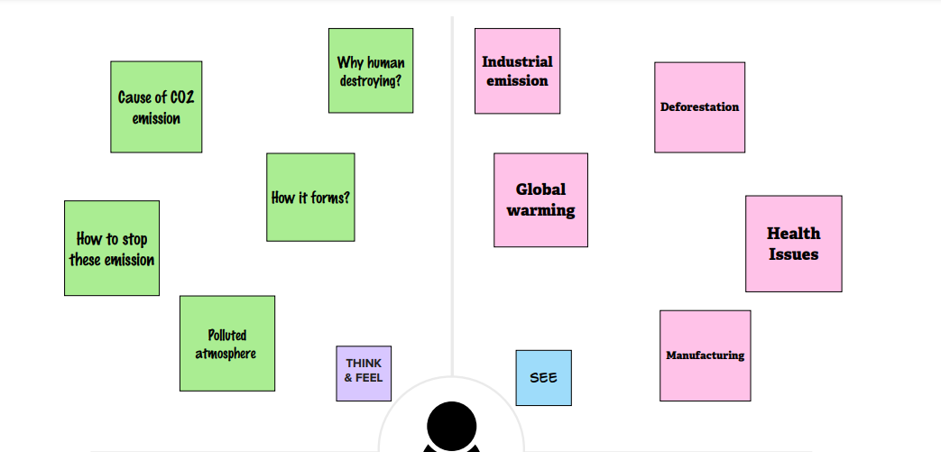

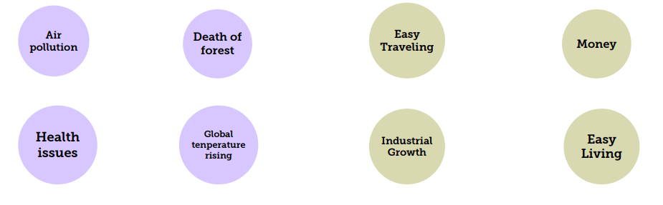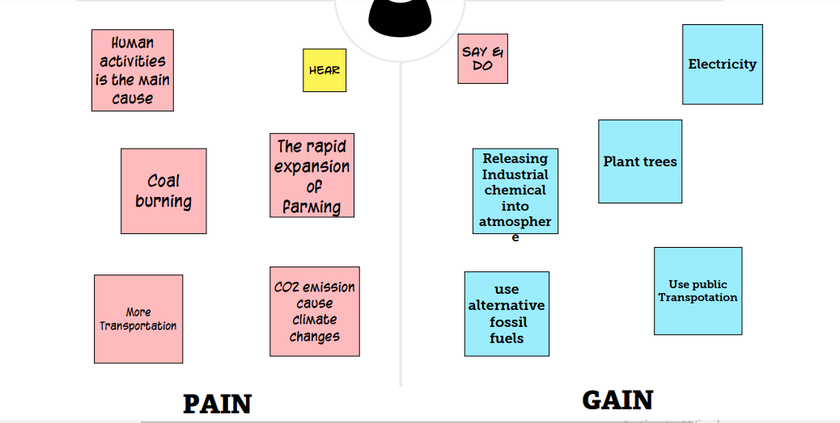

2.2 Ideation & Brainstorming Map

**Brainstorming**is a way of generating ideas and organising your thinking on a topic. It can take shape as a simple list, an outline or a mind map.

* Once you have generated some ideas, you can evaluate and organise them, and narrow down your focus
* Brainstorming is a method of generating ideas and sharing knowledge to solve a particular commercial or technical problem, in which participants are encouraged to think without interruption. Brainstorming is a group activity where each participant shares their ideas as soon as they come to mind. At the conclusion of the session, ideas are categorised and ranked for follow-on action.

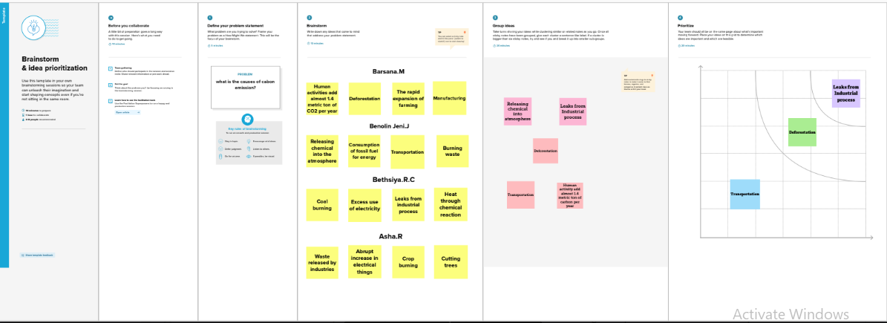

3 RESULT

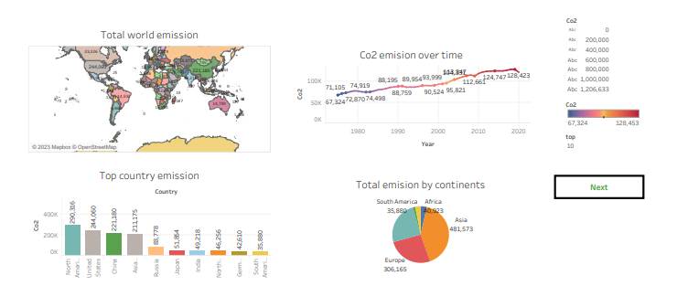

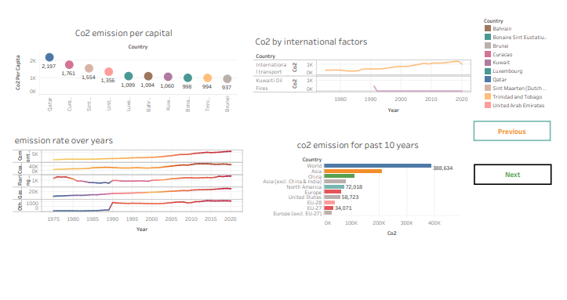

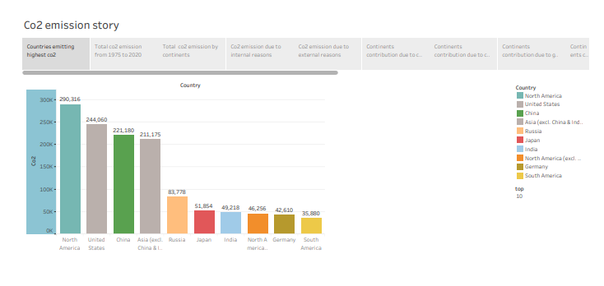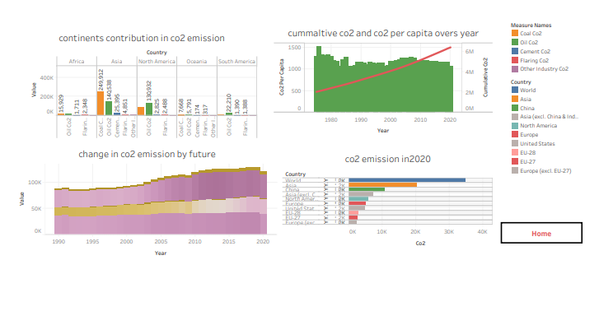

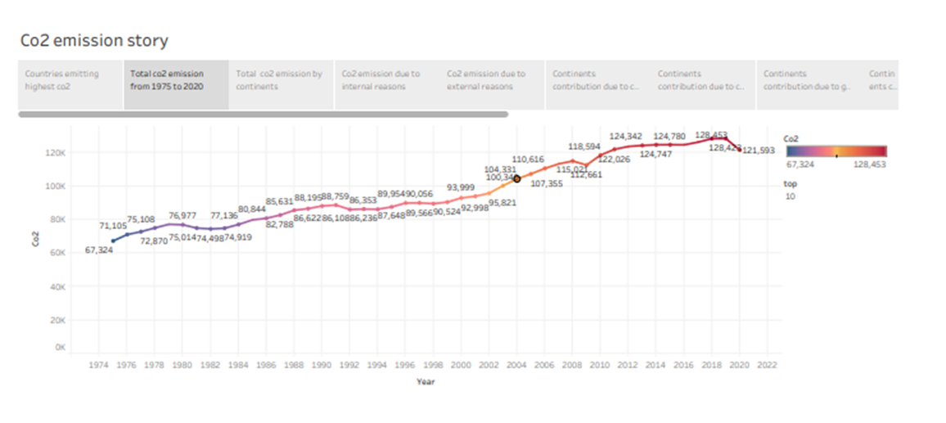

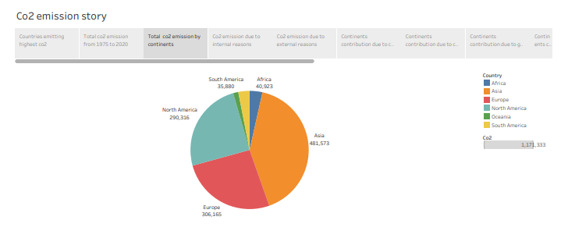

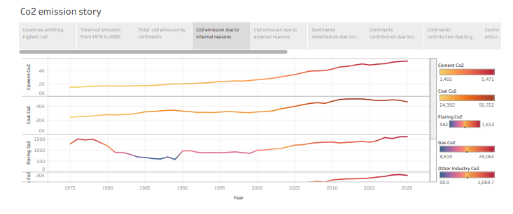

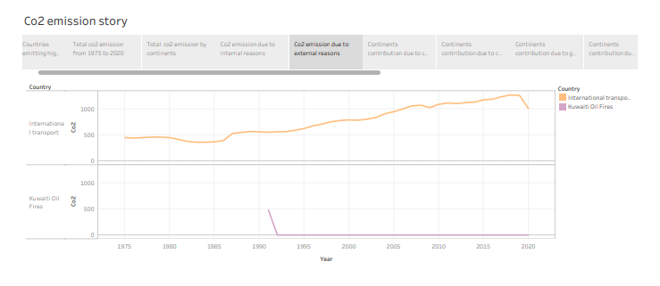

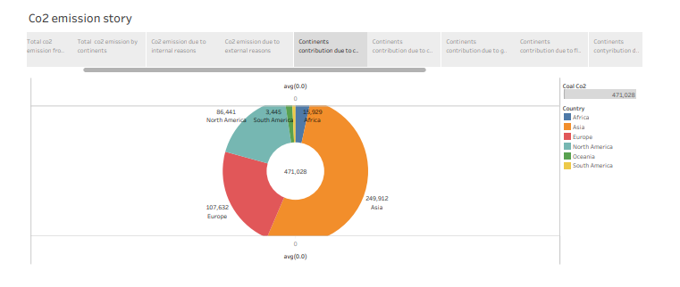

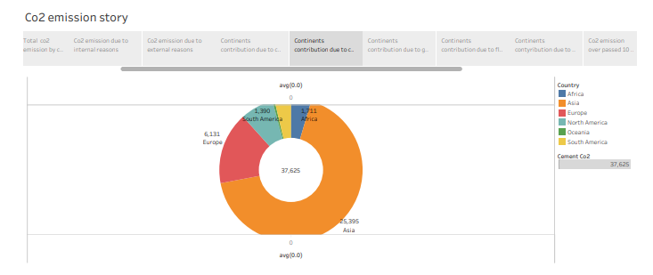

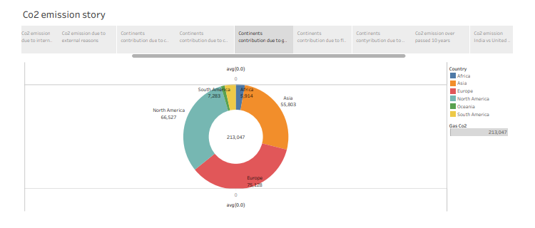

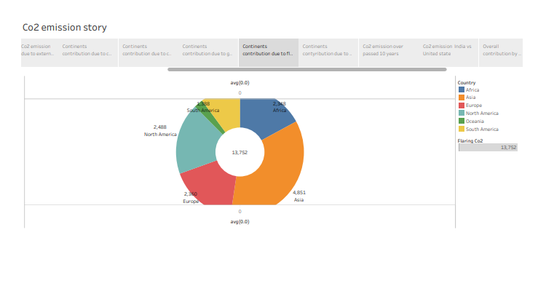

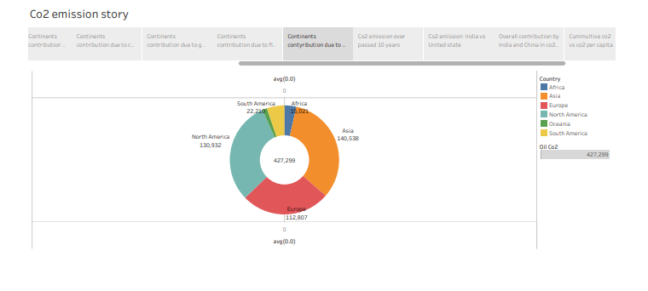

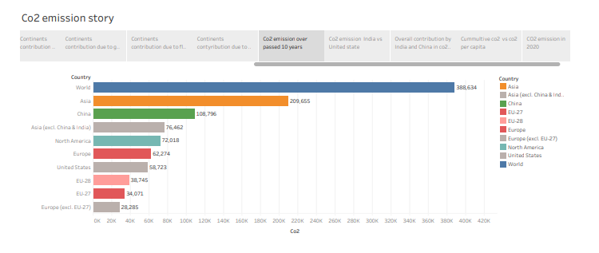

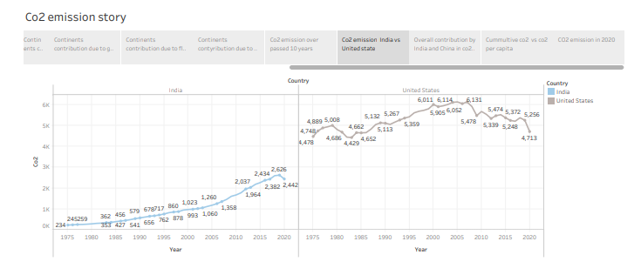

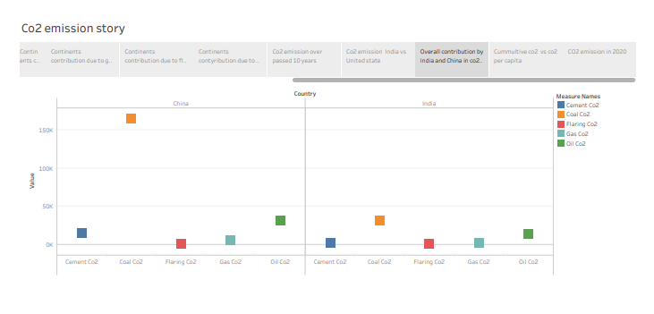

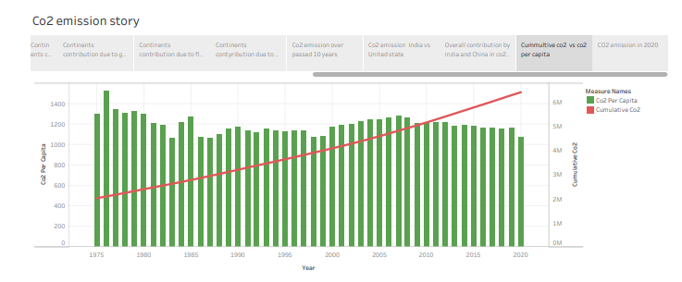

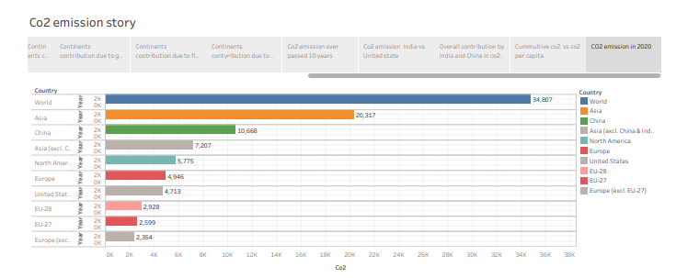

4 ADVANTAGES & DISADVANTAGES

4.1 Advantage of Co2 emission

Carbon capture and storage is one of the most efficient methods of extracting carbon emissions permanently from the environment.

The numerous advantages of CCS include economic, social, and environmental, and a massive impact on a global and local scale.

Carbon capture can increase the power generated with carbon dioxide-based steam cycles. In this process, carbon dioxide is pressured through a supercritical fluid, which could transfer heat more effectively and require less energy to compress steam.

Geologically stored carbon dioxide might be utilized to retrieve geothermal heat from the area injected which results in the generation of sustainable geothermal energy.

Carbon dioxide captured with carbon capture can also be utilized in the manufacturing of polymers and chemicals such as polyurethanes.

The captured carbon dioxide is incorporated into concrete to reinforce it and increase the durability of the infrastructure. The carbon capture operations create employment for skilled engineers and technicians who need to operate them

4.2 Disadvantage of Co2 emission

Carbon capture reduces the carbon released in the atmosphere and therefore, it is recognized as one of the solutions to help address climate change and global warming. Despite this, carbon capture and storage (CCS) does not come without some disadvantages.

The methods and CCS technologies that are necessary for carbon capture have some cost implications attached to them. Therefore, it can be very costly for power plants to generate electricity through fossil fuels. There are several concerns with respect to the safety of the storage of carbon dioxide in huge volumes at a single location due to the possibility of leakages, which can lead to environmental contamination if not handled correctly.

The possibility of leakages could also be a result of natural disasters such as earthquakes or can be a result of human-induced incidents such as damage as a result of wars that can damage underground storage reservoirs.

Many critics have questioned the cost efficiency of basalt formation storage. For this option, 25 tons of water will be required for each ton of carbon dioxide to be buried. There is a possibility that volcanic rock microbes can also digest the carbonates and hence produce methane gas which can be another problem.

Another disadvantage of carbon capture storage is that it is not adequate to successfully deal with climate change. The emissions that come from heat and power generation as a result of using fossil fuels only account for about 25% of the total greenhouse gas (GHG) emission, while 60% of all greenhouse gas emissions come from transportation, agriculture, and other related industrial activities. These emissions are currently not being captured by carbon capture and storage.

5 APPLICATIONS

Reducing Greenhouse Gas Emissions Can **Improve Air Quality and Save Lives**. Reducing global greenhouse gas emissions to slow climate change could prevent millions of premature deaths due to air pollution over the next century.

6 CONCLUSION

Demonstration of [CO2](https://www.greenfacts.org/glossary/abc/carbon-dioxide.htm) capture on this scale is needed to establish the reliability and environmental performance of different types of power systems with capture, to reduce the costs of CCS, and to improve confidence in the cost estimates. In addition, large-scale implementation is needed to obtain better estimates of the costs and performance of CCS in industrial processes, such as the cement and steel industries, that are significant sources of [CO2](https://www.greenfacts.org/glossary/abc/carbon-dioxide.htm) but have little or no experience with [CO2](https://www.greenfacts.org/glossary/abc/carbon-dioxide.htm) capture. .

7 FUTURE SCOPE

Global greenhouse gas emissions (GHG) for 2022 will be 58 gigatons (GT), the largest annual level ever recorded. If current economic growth, demography, and emissions intensity trends continue, the level of emissions will continue to rise, reaching 62 GT by 2030.

8 APPENDIX

Source code

Global Co2 Emission Analysis